CS 255 System Design Document Template

UML Diagrams

UML Use Case Diagram
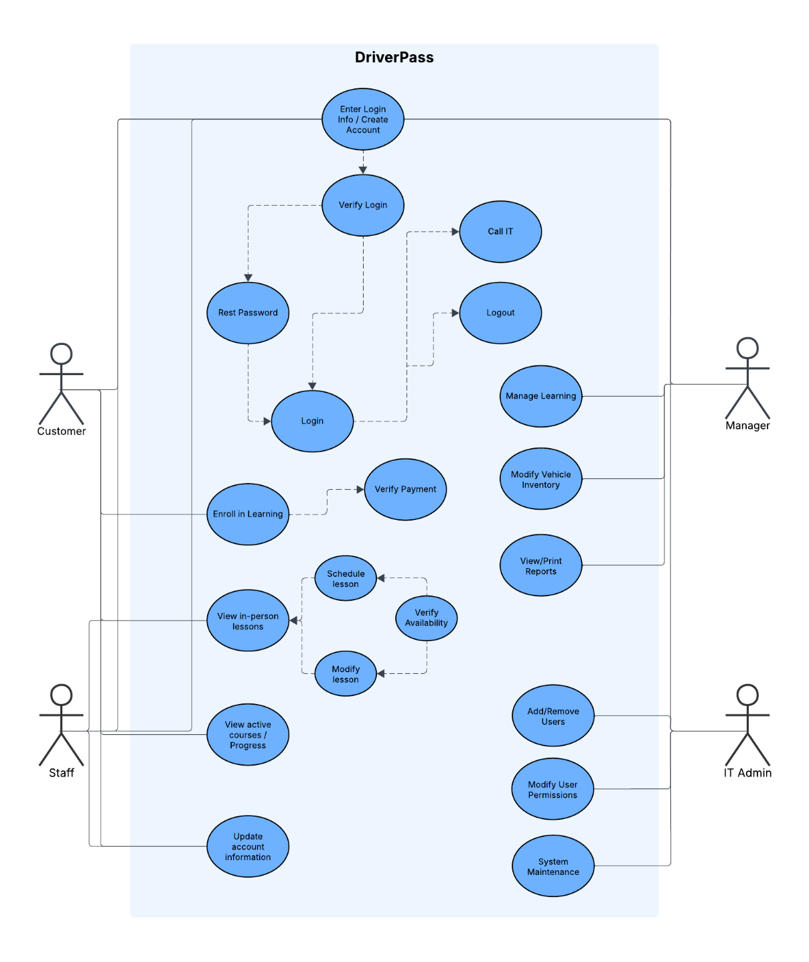

UML Activity Diagrams
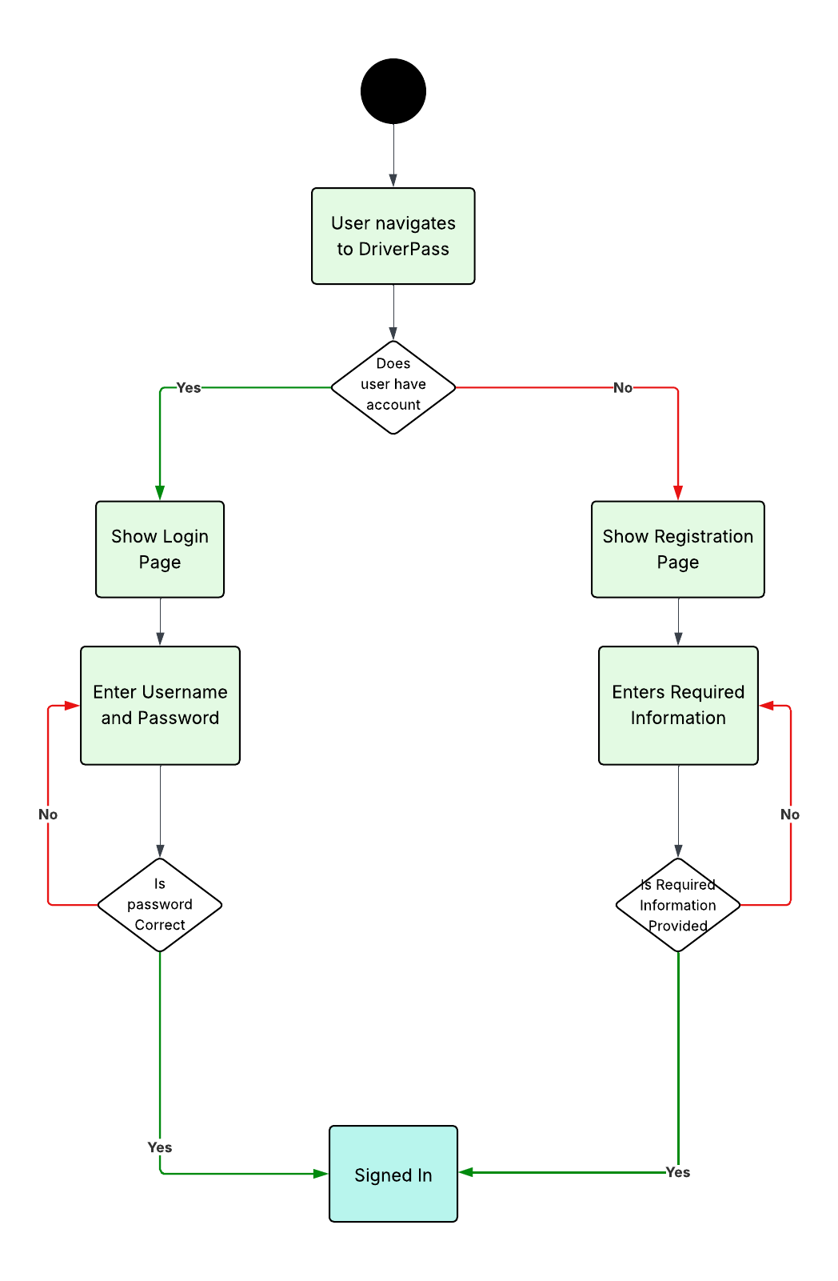
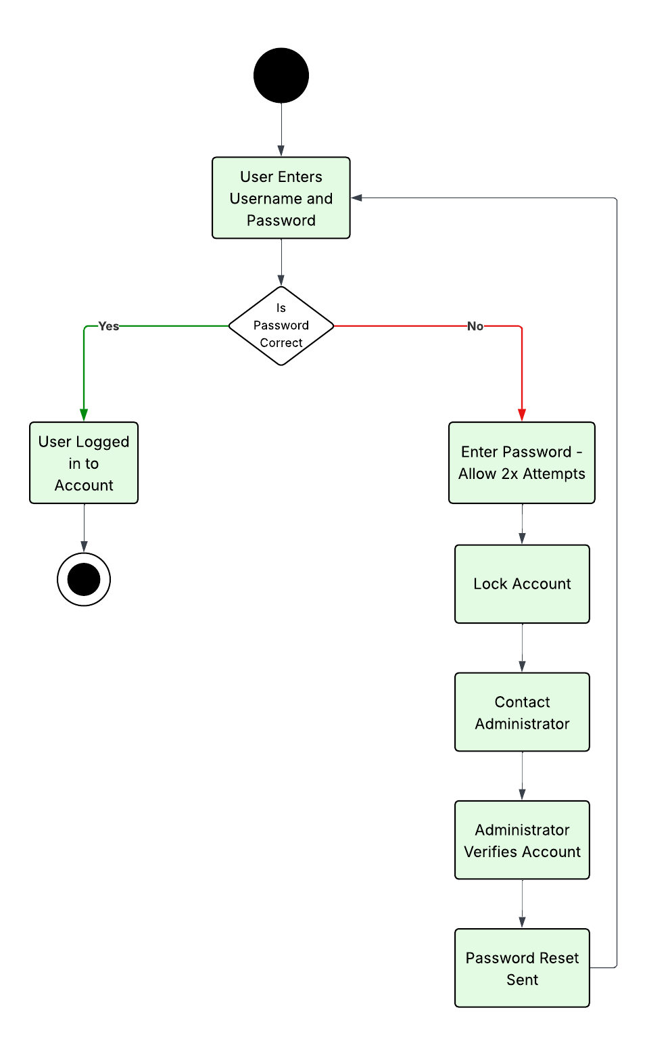

UML Sequence Diagram
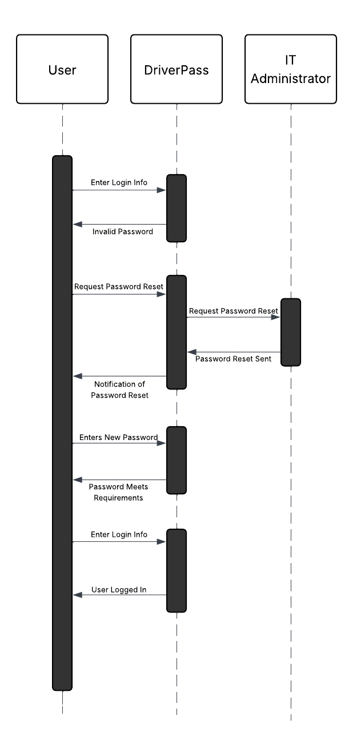

UML Class Diagram
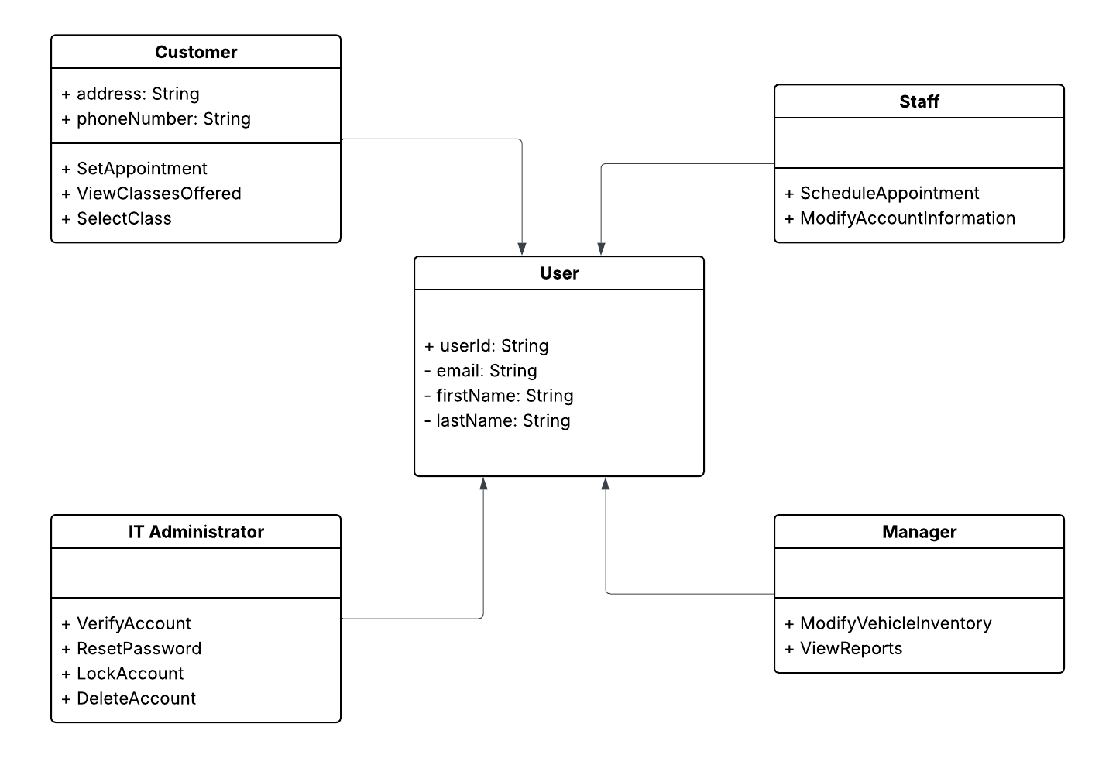

Technical Requirements
A few of the technical requirements, as outlined above, are:
- Hardware
  - Server
  - User Device for access
- Software
  - Security/Firewall
  - User management tools
  - Secure payment tool
  - Server management tools
- Infrastructure
  - Intranet Infrastructure
  - Network connectivity

